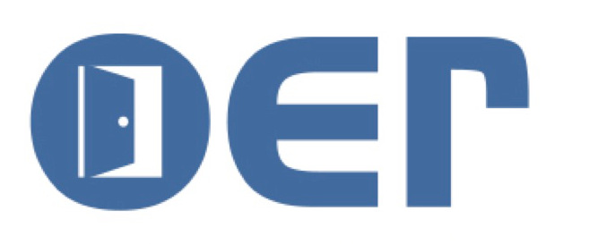

OPEN EDUCATIONAL RESOURCES

  - a menu of open educational resources to retain, reuse, revise, remix, and redistribute for a feast of courses

Textbooks
  - Textbook sources are linked to http://oer.hawaii.edu/links/sources-for-textbooks/
See also OER Commons https://www.oercommons.org/

OpenStax College - Rice University has high quality open textbooks in physics, economics, sociology, psychology, statistics, pre-calculus, algebra, trigonometry, anatomy & physiology, biology, chemistry, and with more to come. Request a faculty login to access support materials and editing rights. Zero Cost
Open Textbook Library - the University of Minnesota Library curates a collection of open textbooks with peer reviews. Drawing from reputable sources OTL references the best in OER college textbooks. Zero Cost

Videos
  - Video sources are linked to http://oer.hawaii.edu/links/video-sources/
See also OER Commons https://www.oercommons.org/

Khan Academy - a beautifully organized collection of YouTube for tutorials on a wide range of K-12 and college level subjects. Zero Cost
  - TedED - TED talks organized into lessons and series, to be used in course instruction; Creative Commons licensing. Zero Cost

Creative Commons Licenses
  - http://creativecommons.org and https://wiki.creativecommons.org/
Attribution | Attribution  NoDerivatives | Attribution  NonCommercial | Attribution  NonCommercial  ShareAlike | Attribution  NonCommercial  ShareAlike | Attribution  ShareAlike

  - See Open Washington Attribution Builder http://www.openwa.org/attrib-builder/ for help in creating an attribution.

