agenda

Chancellor’s Advisory Council Meeting
Place: Kōpiko 127B/128
Date: Tuesday, November 12, 2019
Time: 2:30-4:30 pm

CAC Member: Lisa Aganon, Maria Bautista, Candy Branson, Sarah Bremser, Laure Burke, Angela Coloretti-McGough, Jerilynn Enokawa, Dave Evans, Bob Franco, Shirl Fujihara, Brian Furuto, Carl Hefner, Carol Hoshiko, Grant Itomitsu, Lisa Kanae, Justin Kashiwaeda, Linda Katsuda, Deneen Kawamoto, No‘eau Keopuhiwa, Sheila Kitamura, Kapulani Landgraf, Anne Matute, Dessa Lyn Millon, Karl Naito, Melissa Nakamura, Nāwa`a Napoleon, Sean Nathan, Veronica Ogata, Joe Overton, Louise Pagotto, Devon Ishii Peterson, Lisa Radak, John Richards, John Ridgeway, Shannon Sakaue, Craig Spurrier, Annie Thomas, Don Westover, Joanne Whitaker, Amy Patz Yamashiro, and Jeff Zuckernick.

Guest: Mitchell Ochi, UH System Information Technology Services (ITS), Client Service & Operations Center

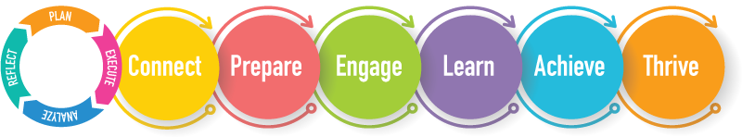

Agenda Item (30 minutes) | Who | Outcomes
Call to Order and Spotlight | Laure Burke, Dave Evans, and Grant Itomitsu | Spotlight on Ignite Internship Program
Approval of minutes from the CAC meeting on October 8, 2019 | Louise P. | Vote to approve
AGO Updates | AGO Chairs/President | Updates from the AGOs.

(1 hour)

ADA Compliance (30 minutes) | Karl Naito and Mitchell Ochi, UH System ITS
EP 1.207 Service Animals and Emotional Support Animals Policy | Louise P. | Feedback on the policy to send to UH System.
KOP 1.112 Participation in College Decision-Making Processes | Louise P. | Feedback on the Policy
K 9.104 Lecturer Evaluations Policy | Task Force | Present Draft K 9.104
Updated PAIR Process (ARF) | Brian Furuto | Present updated PAIR process

(15 minutes)

Budget Update | Louise P. | Next steps to address the budget.

(15 minutes)

Chancellor Updates | Louise P. | Updates from the Chancellor (CLRs – 20% identified?

Next Meeting: Tuesday, December 3, 2019 at 2:30-4:30pm

Important Dates:

Executing | Who is Responsible? | Date Due
Each program to complete the “Plan” section of the CI + ARPD | Vice Chancellors and Deans | December 1, 2019
Fall CLRs due in PAPAYA Folder | Course Coordinators | January 10, 2020

Policies:

Policy | Feedback  Incorporated | Final | Vote
K 9.104 – Lecturer Evaluations | Nov. 12, 2019 – CAC Mtg. | Dec. 10, 2019 – CAC Mtg. | Feb. 11, 2020 – CAC Mtg.
KOP 1.112 – Participation in College Decision-Making Processes | Nov. 12, 2019 – CAC Mtg. | Dec. 10, 2019 – CAC Mtg. | Feb. 11, 2020 – CAC Mtg.
EP 1.207 – Service Animals (UH System Review Process) | Nov. 12, 2019 – CAC Mtg. | Nov. 25, 2019 – Google Doc | No Vote - Send comments to UH System

